Amitabh Chakravorty

Date: 3/13/2022

**IBM Employee Attrition Insights**

After analyzing the Employee Attrition data of IBM, I have found that 83.88% of the total employees decided to stay and 16.12% of the employees have left. The frequency table illustrates that the majority of the employees at IBM are Laboratory Technicians (17.62%), Research Scientists (19.86%) and Sales Executives (22.18 %).

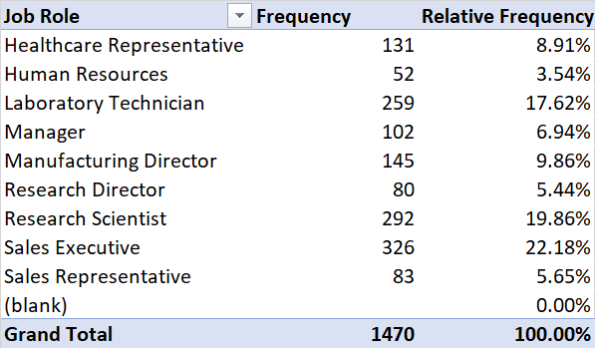

According to the cross tabulations, most of the attrition employees have worked 0 to 10 years at IBM, 5.17% and 5.58% employees with working years 0-5 years and 5-10 years respectively left the firm. The least of the attrition employees have worked for 25 to 40 years.

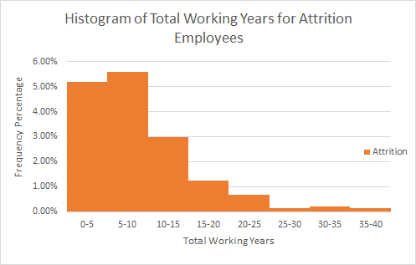

|  |  |  |  |
| --- | --- | --- | --- |
| **Total Percentage** | **Attrition** |  |  |
| **Total Working Years** | **No** | **Yes** | **Grand Total** |
| 0-5 | 10.41% | 5.17% | 15.58% |
| 5-10 | 27.96% | 5.58% | 33.54% |
| 10-15 | 21.02% | 2.99% | 24.01% |
| 15-20 | 9.59% | 1.22% | 10.82% |
| 20-25 | 7.82% | 0.68% | 8.50% |
| 25-30 | 3.81% | 0.14% | 3.95% |
| 30-35 | 2.31% | 0.20% | 2.52% |
| 35-40 | 0.95% | 0.14% | 1.09% |
| **Grand Total** | **83.88%** | **16.12%** | **100.00%** |

This data demonstrates that employees mostly make their decision to stay or to leave the company in the early stage of their career.

The cross tabulation of Years Since Last Promotion and Attrition reflects that the majority of the employees at IBM who decided to stay had their last promotion 0 year (32.04%) or 1 year (20.95%) ago. As the number of years since the last promotion increases, the percentage of staying employees tends to decrease. This negative correlation between the number of years since the last promotion and percentage of staying employees highlights that recently promoted employees have a higher incentive to stay at IBM.

|  |  |  |  |
| --- | --- | --- | --- |
| **Total Percentage** | **Attrition** |  |  |
| **Years Since Last Promotion** | **No** | **Yes** | **Grand Total** |
| 0 | 32.04% | 7.48% | 39.52% |
| 1 | 20.95% | 3.33% | 24.29% |
| 2 | 8.98% | 1.84% | 10.82% |
| 3 | 2.93% | 0.61% | 3.54% |
| 4 | 3.81% | 0.34% | 4.15% |
| 5 | 2.93% | 0.14% | 3.06% |
| 6 | 1.77% | 0.41% | 2.18% |
| 7 | 4.08% | 1.09% | 5.17% |
| 8 | 1.22% | 0.00% | 1.22% |
| 9 | 0.88% | 0.27% | 1.16% |
| 10 | 0.34% | 0.07% | 0.41% |
| 11 | 1.50% | 0.14% | 1.63% |
| 12 | 0.68% | 0.00% | 0.68% |
| 13 | 0.54% | 0.14% | 0.68% |
| 14 | 0.54% | 0.07% | 0.61% |
| 15 | 0.68% | 0.20% | 0.88% |
| **Grand Total** | **83.88%** | **16.12%** | **100.00%** |

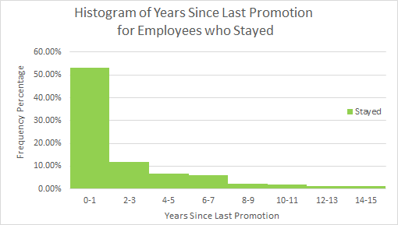

The correlations table demonstrates that there is a strong relationship between Total Working Years and Years at IBM, correlation coefficient between these two variables is approximately 0.62. This underlines that most of the employees at IBM have spent most of their career at IBM. The correlation of both Years in Current Role and Years at Company is strong with the Years with Current Manager, the correlation coefficients are approximately 0.71 and 0.77 respectively. This highlights that employees tend to stay in their current role and work more years at IBM according to the presence length of their current managers.